JW MARRIOTT MARQUIS HOTEL SHANGHAI PUDONG

LOCAL STANDARD OPERATING PROCEDURE

LSOP No.: FC-HSKP-FC005 Effective Date: Oct 12, 2024

Division: Rooms Revised Date:

Section: Fitness Center Prepared by: Fitness Center Manager

Reviewed by: Director of Rooms Approved by: General Manager

SUBJECT 题目: Fitness center linen control
健身中心布草控制与管理

OBEJECTIVE目标

Ensure linen quality good and daily control management.
确保健身中心使用布草的状态良好及日常管理。

POLICY 政策

Every day, the fitness center sends towels using by FC linen cart. Before sending them to Laundry space tap the number and make a record.
每日健身中心送洗毛巾装入指定布草车，送往洗涤中心前自行轻点数字并做好记录。

Daily deliver linen time at 8:00am, and received at 12:00, in high-season additional received at 4pm per every day.
每日送洗时间为8:00am，每日取回时间为12:00，夏季高峰期16:00额外增加一次送回。

After retrieving the linen daily, counting the towel and fold it into the towel cabinet.
每日取回布草后进行清点并折叠好放入装用毛巾柜。

Keep the towel cabinet door closed at all times to keep the linen room clean and tidy.
时刻保持毛巾柜门关闭，以保持布草间的干净整洁。

Conduct OE inventory every quarter, conduct data analysis, and carry out the scrapping process for damaged towels.
每季度进行OE盘点，进行数据分析，对于破损毛巾进行报废流程的操作。

附件1：FC Linen Daily Check List 2024
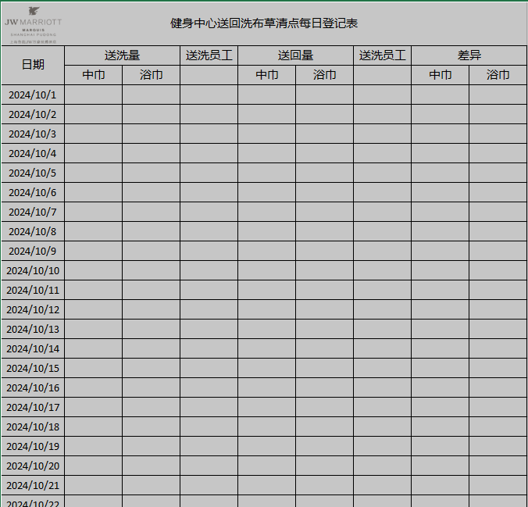

附件2：SPOILAGE & BREAKAGE APPROVAL FORM 用于日常破损报废单之用

